Website Idea:

-Why will people come to my site? People will visit my site to gain information about my utility construction experience. This will include peers and future employers.

-What questions will your visitors expect your site to answer for them? They will expect to see how much time I have been in the industry, what kind of equipment I have operated, what skills and certifications I have, what companies I have worked for, locations I have worked and their soil types, and what different utilities I have worked with.

-What types of activities will visitors want to complete on your site? Visitors will be able to view an interactive map, view images, view contact information, leave a message to me, and view the different informative texts.

-What information is necessary to complete any actions your site offers? There will be a necessary background in utility construction to fully appreciate and understand the expressed information on my site. The intended audience will have the necessary background information.

-Why will your visitors come to your site instead of another to get this information or complete the actions? The alternative to this site would probably be LinkedIn, but I feel like my site is a much better display and would be a more interactive way to navigate the information.

MAIN PAGE

I will have a page that shows a good summary of the information I will express with the site. It will have the most basic and vital information from the other pages for visitors that don’t want to go too in depth of the site. It will also act as an attention grabber so visitors that are interested will visit the other pages. This pages will include a basic summary paragraph of the purpose of the site such as:

“My name is Kurtis Smith, I have been in the utility construction industry since 2021. I pride myself in my skills as an HDD Locator. I’ve located with Subsite, UMag, and Digitrak locators. I have also worked as a driller operating a Ditchwitch JT25. I’ve installed up to 4” conduit, down to 1-way Mirco Duct conduit. I’m a very versatile worker and I have proved to be an asset in any project I’m put to work on. “

This page will have a collection of images of the logos of the companies I have worked for as well as companies I have done bores for with those companies.

Companies I’ve worked for:

-Fybercom

-Diversified Solutions Incorporated

-Big Sky Utilities

Companies I’ve done bores for:

-Fybercom

-Charter Spectrum

-Blackfoot Communications

-Grizzly Broadband

Images:

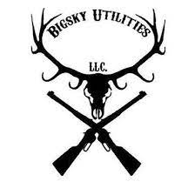



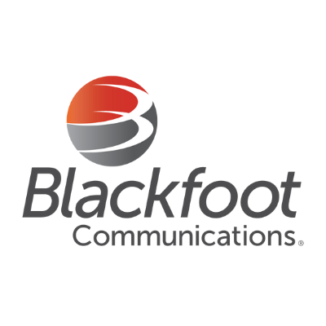



SKILLS AND CERTIFICATIONS

This page would display my skills such as what equipment I know how to operate, what tasks I know how to complete,

Equipment I have experience operating:

-Drills

-Ditch Witch JT25

-Ditch Witch JT30

-Plows

-Ditch Witch RT55

-Ditch Witch RT120 Quad Track

-Excavation

-Backhoe

-Mini Excavators

-Hydrovac Trailers

-Drop Line Installation

-Mini Skid Steers

-Vibratory Plows

-Utility Locators

-Ditch Witch Utiliguard T5

-Leica DD120

-HDD Drill Locators

-Ditch Witch Subsite TK

-Ditch Witch Subsite TK Recon 1

-UMag 8

-Digitrak SE

-Digitrak F2

-Digitrak F5

-Miscellaneous

-Hammerhead Moles

-Air Compressors

-Fluid Mixing Systems

-Reel Trailers

Skills and Tasks:

-Basic skills:

-Driving large trucks with heavy trailers

-Working around utilities safely

-Understanding general safety procedures

-Potholing

-Restoration

-Handhole / Junction Box Installation

-HDD Drill Operator

-HDD Drill Locator

-Equipment Operator

-Drop Line Technician

-Plow Operator

-Utility Locator

-Other Skills

-Ground Mole Operation

-General Laborer

I’ll incorporate a way to mesh those two lists of information into cards that they are applicable to.

Images

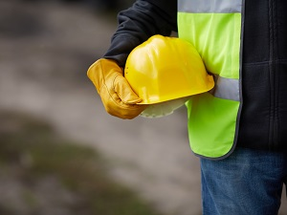

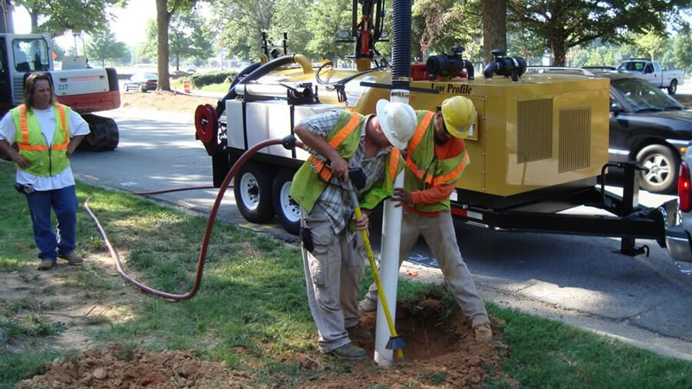

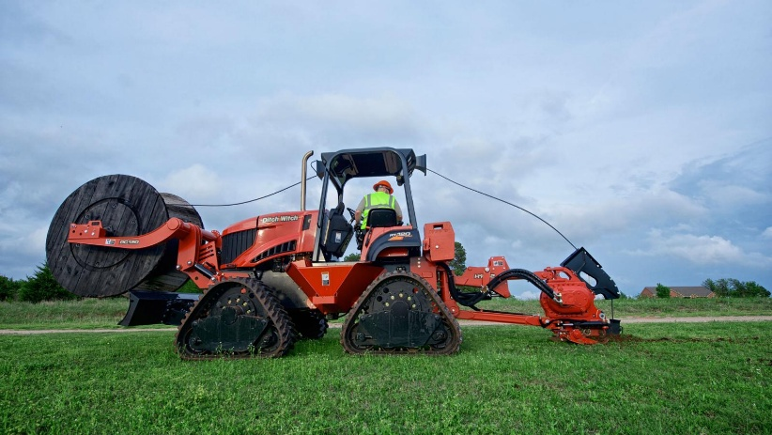

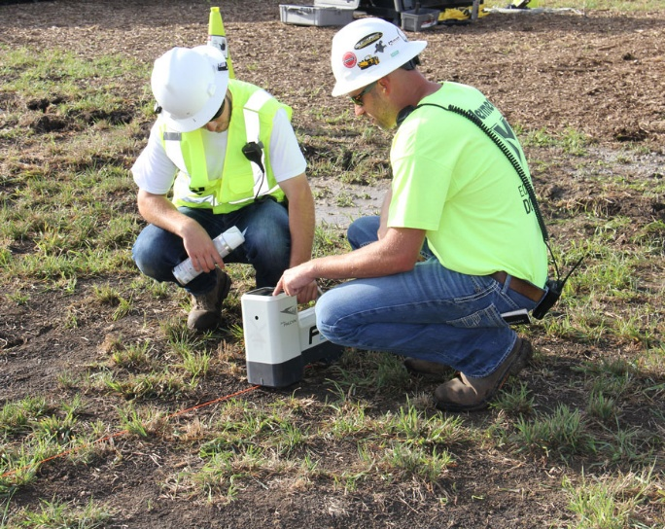

EXPERIENCE

On this page, I’ll give a brief description of what I did for the different companies that I’ve worked for, including: what tasks I did for each company, where I worked with that company, what work we were doing, etc.

Fybercom:

-Brief Description: Fybercom is an Internet Service Provider for south east Idaho. I started at Fybercom in 2021 as a general laborer. I worked my way up to an HDD drill locator, using a UMag 8 and Subsite TK Recon 1, using drill-to locating styles. Then I was promoted to an HDD drill operator, operating a Ditch Witch JT25 and Ditch Witch JT30. I did various tasks while at Fybercom but all work was done to add fiber optic infrastructure to Fybercom’s network.

-Tasks

-General Laborer

-Potholing

-Restoration

-Drop Line Technician

-Equipment Operator

-Utility Locator

-HDD Drill Locator

-HDD Drill Operator

-Ground Mole Operation

-Where

-Shelley, Idaho

-Idaho Falls, Idaho

-Iona, Idaho

-Ucon, Idaho

-Rigby, Idaho

-Ririe, Idaho

-Rexburg, Idaho

-Island Park, Idaho

Diversified Solutions Incorporated: Diversified Solutions Incorporated is a utility construction sub-contractor. I was hired as an HDD drill locator to locate with a Subsite TK but spent a large amount of time doing drop line installations and working operating a Ditch Witch RT120 Quad Track plow. All work was done for Blackfoot Communications, adding to their coax and fiber optic network in primarily Island Park.

-Tasks

-General Laborer

-Restoration

-Drop Line Technician

-Plow Operator

-HDD Drill Locator

-Where

-St Anthony, Idaho

-Island Park, Idaho

Big Sky Utilities: Big Sky Utilities is a travelling directional drilling subcontractor based in Western Montana. I was hired as a general laborer, but later got promoted to an HDD drill locator. I located using Digitrak locators using drill-to and traditional locating styles. We travelled for work and worked for multiple different ISP’s. We would work anywhere from Whitefish, Montana to Butte, Montana. We did bore shots for Grizzly Broadband, Charter Spectrum, and various miscellaneous shots.

-Tasks

-General Laborer

-Potholing

-Restoration

-HDD Drill Locator

-Where

-Butte, Montana

-Hamilton, Montana

-Corvallis, Montana

-Helena, Montana

-Missoula, Montana

-Big Fork, Montana

-Kalispell, Montana

-Whitefish, Montana

Page won’t have any images but will include a google map of the cities listed.

CONTACT ME

This page will be pretty simple. There will be a text box where someone can leave a message to me on my website. There will also be a phone number to text or call if they would rather do that than leave a message on the site. There will be an email displayed as well.

Images:

